◥ REPORT

# BIOMATERIALS

A bioinspired flexible organic artificial afferent nerve

Yeongin Kim,1* Alex Chortos,2* Wentao Xu,3,4*† Yuxin Liu,5 Jin Young Oh,6,7

Donghee Son,6 Jiheong Kang,6 Amir M. Foudeh,6 Chenxin Zhu,1 Yeongjun Lee,3

Simiao Niu,6 Jia Liu,6 Raphael Pfattner,6 Zhenan Bao,6† Tae-Woo Lee3†

The distributed network of receptors, neurons, and synapses in the somatosensory system efficiently processes complex tactile information. We used flexible organic electronics to mimic the functions of a sensory nerve. Our artificial afferent nerve collects pressure information (1 to 80 kilopascals) from clusters of pressure sensors, converts the pressure information into action potentials (0 to 100 hertz) by using ring oscillators, and integrates the action potentials from multiple ring oscillators with a synaptic transistor. Biomimetic hierarchical structures can detect movement of an object, combine simultaneous pressure inputs, and distinguish braille characters. Furthermore, we connected our artificial afferent nerve to motor nerves to construct a hybrid bioelectronic reflex arc to actuate muscles. Our system has potential applications in neurorobotics and neuroprosthetics.

W

hereas classical von Neumann–based by several conventional silicon transistors and a computing systems rely on centralized capacitor (16).

and sequential operations determined Device structures that emulate the functionalby a clock, neurons and synapses in ity and signal processing of biological compobiological nervous systems process in- nents may potentially simplify complex circuits formation on the basis of distributed, parallel, by mimicking multiple synapses with a single and event-driven computation (1). As a result, device. Organic devices are attractive because classical systems exhibit the advantages of high their characteristics can be tuned through chemspeed and accuracy for well-defined problems, ical design (17, 18), they are compatible with and biological systems are compact, fault toler- printing methods that enable large-area coverant, and power efficient for complex real-world age at a low cost (13), and they have relatively low problems, such as visual information processing, elastic moduli, similar to those of soft biological speech recognition, and movement control. Bio- systems.



logical systems have influenced many fields of The development of neuromorphic systems science and engineering, such as neuromorphic that mimic the sense of touch can benefit from computing (2–5), bioinspired sensing systems the improved understanding of information pro(6–9), control theory for legged robots (10, 11), cessing in somatosensory peripheral nerves. and prosthetics (12–14). The branched structure of slowly adapting type I

Biologically inspired systems have been imple- (SA-I) afferent (sensory) neurons, which leads mented at the software level in classical von to a complex receptive field with many hotspots, is Neumann–based systems to distinguish braille critical for sensing at a spatial resolution smaller characters (15) and control actuators in legged than the spacing between the receptive field cenrobots (10, 11). Alternatively, complex silicon cir- ters (fig. S1) (19), discerning the movement of obcuits have been developed to mimic the spike- jects, and distinguishing the orientation of edges based information processing in biological systems, on objects (19). The interneurons in the spinal cord in which the function of a synapse was emulated havealso been found to formsynapses with multiple afferent neurons to encode and separate input features before tactile information is delivered

1

Department of Electrical Engineering, Stanford University, 20, 21).

Stanford, CA, USA. 2Department of Materials Science and to the cortex (

Engineering, Stanford University, Stanford, CA, USA. Here we describe an artificial afferent nerve

3 based on flexible organic electronics (22–25).

Department of Materials Science and Engineering, Seoul

National University, Seoul, South Korea. 4Institute of The bioinspired artificial afferent nerve emu-

Photoelectronic Thin Film Devices and Technology, Nankai

University, Tianjin, China. 5Department of Bioengineering, lates the functions of biological SA-I afferent Stanford University, Stanford, CA, USA. 6Department of nerves (Fig. 1A) by collecting data from multiple Chemical Engineering, Stanford University, Stanford, CA, tactile receptors and conveying this information

USA. 7Department of Chemical Engineering, Kyung Hee to biological efferent (motor) nerves, completing

University, Yongin, South Korea. a hybrid bioelectronic reflex arc. Our artificial

*These authors contributed equally to this work.

†Corresponding author. Email: wentao@nankai.edu.cn (W.X.); afferent nerve (Fig. 1, B and C, and fig. S2) conzbao@stanford.edu (Z.B.); twlees@snu.ac.kr (T.-W.L.) sists of three core components: resistive pressure

on November 27, 2019

[http://science.sciencemag.org](http://science.sciencemag.org/)

[/](http://science.sciencemag.org/)

Downloaded from

sensors, organic ring oscillators, and a synaptic transistor. Artificial mechanoreceptors consisting of a cluster of pressure sensors (each pressure sensor corresponds to a hotspot in the receptive field) are connected to an artificial nerve fiber (a ring oscillator) that converts external tactile stimuli into voltage pulses. The electrical signals from multiple artificial nerve fibers are then integrated and converted into postsynaptic currents by a synaptic transistor. The synaptic transistor can be subsequently used to interface with biological efferent nerves to form a complete monosynaptic reflex arc.

The resistive pressure sensors (13), with a sensitivity and working range comparable to those of biological receptors, are composed of a conducting pyramid-structured elastomer that forms a resistive pathway between CNT (carbon nanotube) and Au electrodes (Fig. 1B and fig. S3). An increase in pressure increases the contact area and therefore decreases the resistance between the CNT electrode and the Au electrodes (Fig. 2A).

The organic ring oscillator (figs. S4 and S5) was made of odd numbers of pseudo–complementary metal-oxide semiconductor (CMOS) inverters (figs. S6 and S7). The ring oscillator was designed to oscillate at frequencies that match the action potentials of sensory neurons (0 to 100 Hz) (supplementary text) (26). Frequencyencoded information can be more robust to voltage degradation and parasitic resistances than amplitude-encoded information. The supply voltage to the ring oscillator increased with the pressure on the sensor (Fig. 2A). The oscillation of the ring oscillator is “off” and the power consumption decreases (though not to 0 W because of the pseudo-CMOS design) when there is no pressure on the sensor. A constant nonzero pressure input leads to a fixed supply voltage to the ring oscillator, resulting in a constant frequency output that can be easily used to calculate the pressure input on the basis of a 1-to-1 relationship between pressure inputs and concurrent ring oscillator outputs, but this constant input also increases power consumption compared with that of biological SA-I afferent nerves, which have slow sensory adaption (supplementary text). An increase in pressure intensity resulted in an increase in both the frequency and the peak amplitude of electrical impulses from the oscillator (Fig. 2B). This is slightly different from the case in biology, in which the amplitudes of action potentials are usually the same (supplementary text).

The synaptic transistor (17, 27, 28) was fabricated with the use of a solution-processed conjugated polymer (the compound P1) (fig. S8B) as the hole-transporting semiconductor and an ion gel as the gate dielectric (figs. S8 to S11). Although the synaptic transistor was more limited in its capacity for run-time tuning of the temporal dynamics during operation (fig. S12) than the rather complex silicon synapse consisting of several transistors and a capacitor (16), we were able to obtain decay times for postsynaptic currents (typically 2 to 3 ms) (fig. S13) in a range comparable

on November 27, 2019

[http://science.sciencemag.org](http://science.sciencemag.org/)

[/](http://science.sciencemag.org/)

Downloaded from



to that of decay times for synapses of biological

afferent nerves (1.5 to 5 ms) (

21

,

29

)

by choos

-

ing a specific polymer semiconductor during

fabrication (table S1). The large variation in de-

cay times within a material should have minimal

effect on the output (

30

. The voltage outputs

)

from the ring oscillators were connected to the

gate electrodes of the synaptic transistor. The

frequency of the current output from the syn-

aptic transistor (Fig. 2C) matched the frequency

of the voltage output from the ring oscillator

-

(

Fig. 2B). However, the pressure-current out

put from the synaptic transistor (Fig. 2C) was

more linear than the pressure-voltage output

of the ring oscillator (Fig. 2B). Our artificial af-

ferent neuron consumes ~8

m

W in the

“

off

”

state

and ~25

m

W in the

“

on

”

state (fig. S14). An array

of our artificial afferent neurons can lead to a

flexible artificial afferent nervous system

—

one of

spiking neural networks (supplementary text)

—

with lower power consumption than the sys-

tem consisting of a conventional flexible one-

transistor

–

one-resistor pressure sensor array

connected to Si-integrated circuit chips, which

consume additional power for readout and

control (fig. S15 and table S2).

Prolonged presynaptic voltage spikes can

lead to more anion accumulation near or in

the organic semiconductor and then increase

the amplitude of postsynaptic currents (

31

).

The peak postsynaptic currents are influenced

by not only the magnitude of the pressure stim-

ulus (Fig. 2, C and D) but also the duration of

the pressure stimulus (Fig. 2, E and F). The du-

ration of the pressure stimulus does not change

voltage outputs from the ring oscillator. When

we applied 500 cycles of 2-s pressure stimula-

tion every 10 s (fig. S12), we detected slight in-

creases in the postsynaptic currents and the

decay times.

The synaptic transistor can combine signals

from multiple ring oscillators because the ion

gel allows the active channel to be gated by mul-

tiple electrodes (Fig. 3A and fig. S10C). The post-

synaptic currents resulting from the pressures

simultaneously applied to two pressure sen-

sors (Fig. 3D) were comparable to the sum of

the currents resulting from a pressure applied

to two individual sensors (Fig. 3E = Fig. 3B +

Fig. 3C). In the Fourier transform of each case

Fig. 3F), the synaptic transistor could combine

(

signals from two pressure sensors and gener-

ate postsynaptic currents consisting of two fre-

quency components corresponding to those

from the two pressure sensors. Analogous to

the way in which dendrites of a postsynaptic

neuron in connection with a number of bio-

logical synapses add action potentials from

multiple presynaptic neurons, a single synap-

tic transistor can add voltage inputs coming

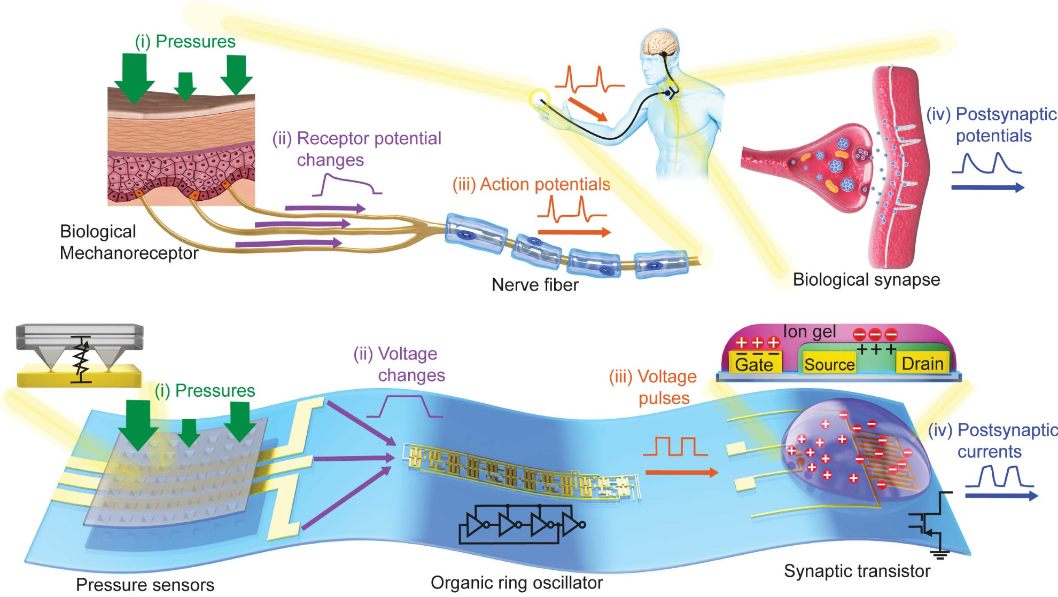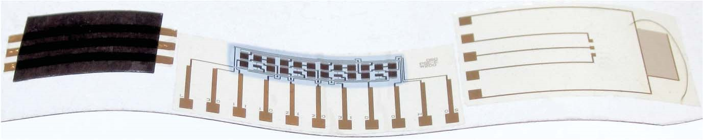

Fig. 1. An artificial afferent nerve system in comparison with a

biological one.

(

A

)

A biological afferent nerve that is stimulated by

pressure. Pressures applied onto mechanoreceptors change the receptor

potential of each mechanoreceptor. The receptor potentials combine

and initiate action potentials at the heminode. The nerve fiber forms

synapses with interneurons in the spinal cord. Action potentials from

multiple nerve fibers combine through synapses and contribute to

information processing. (

B

)

An artificial afferent nerve made of pressure

sensors, an organic ring oscillator, and a synaptic transistor. Only one

ring oscillator connected to a synaptic transistor is shown here for

simplicity. However, multiple ring oscillators with clusters of pressure

sensors can be connected to one synaptic transistor. The parts with

the same colors in (A) and (B) correspond to each other. (

C

)

A photograph

of an artificial afferent nerve system.

from multiple ring oscillators. The synaptic transistor thus integrates signals more simply than the traditional synapse circuit made of several transistors and a capacitor, which needs separate circuits per input (16), although the decay time and the synaptic weight of each gate input in our synaptic transistor can be individually tuned only during fabrication, not during operation. Compared with uniformly applied pressures (80 kPa in fig. S16, D and F), pressures of different magnitudes (20 and 80 kPa in Fig. 3, D and F) led to different temporal and spectral patterns of postsynaptic currents. Such patterns could be used to encode information about largescale textures measured by SA-I afferents.

One ring oscillator can combine signals from a cluster of pressure sensors, similar to a biological heminode (the beginning of the myelinated part of a nerve fiber) (26). When multiple pressure sensors are connected in parallel (Fig. 3G), the highest pressure will have a dominant effect on the output of the ring oscillator. This behavior mimics the branched structures and heminodes of afferent nerves that give rise to a sophisticated sense of touch in higher-order animals (26). A rodlike object was moved across two branches of pressure sensors in two different directions (Fig. 3G). When the object moved in the directions of the red and blue arrows, the postsynaptic current outputs had one valley corresponding to the object position between the two pressure sensors (Fig. 3H) and a monotonic increase without any local minimum (Fig. 3I), respectively. Analysis of the temporal profiles of postsynaptic currents in these two cases demonstrates the possibility of a bioinspired approach to recognize the direction and potentially the speed of object movement, which can be estimated from the duration of the valley of postsynaptic currents.

We used our artificial afferent nerves to identify braille characters pressed on an array of three pixels by two pixels (Fig. 3J and fig. S17). Six synaptic transistors accepted inputs from one oscillator, and 11 synaptic transistors each accepted inputs from two different oscillators. The peak frequencies of postsynaptic currents connected to one pixel (marked with a single number, from 1 to 6, and a blue box in fig. S17, A and B) are shown for all six pixels (Fig. 3K and fig. S18A). To quantify the difference in postsynaptic responses between different letters, we used Victor-Purpura spike train metrics (32) to calculate the Victor-Purpura distances (DVP) between the characters (fig. S18, B and C). A larger DVP means more dissimilarity between two spike trains. Compared with the smallest DVP between different letters with the use of only pressure sensors and ring oscillators (i.e., without the signal integration of two pixels), the synaptic signal integration led to an increase in the smallest DVP between different alphabets, which means that braille letters became more distinguishable because of the synaptic integration (Fig. 3L). Thus, this approach mimics the process of tactile information processing in a biological somatosensory system, where the signals of multiple tactile inputs from first-order neurons are integrated by synapses to partially process the information before delivery to the brain (20, 21).

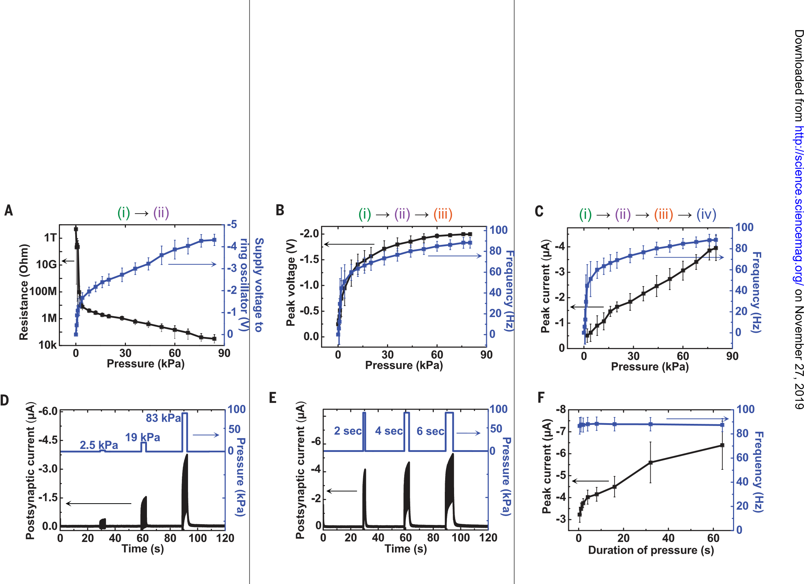We connected our artificial afferent nerve to biological efferent nerves of a discoid cockroach (Blaberus discoidalis) (Fig. 4A) to complete a hybrid monosynaptic reflex arc (Fig. 4B), emulating a biological reflex arc (fig. S19). We used this hybrid system to demonstrate the flow of information from multiple pressure sensors through a neuromorphic circuit to deliver biomimetic postsynaptic oscillating signals into the biological efferent nerves in a detached cockroach leg (Fig. 4C), leading to the actuation of the tibial extensor muscle in the leg (Fig. 4D). The oscillating signals from our artificial afferent nerve elicit action potentials in nerves better than constant voltages (33). An increase in the amplitudeandfrequencyofstimulationsignalsincreases the number of activated muscle fibers and the forces generated by each muscle fiber, respectively (33, 34). When we increased the intensity and

Fig. 2. Characteristics of an artificial afferent nerve system with one branch. (A) Resistance of a resistive pressure sensor and the corresponding change in the supply voltage of an organic ring oscillator in response to the change of pressure. The pressure sensor and the organic ring oscillator formed a voltage divider between a dc power supply voltage and the ground (fig. S2). (B) Peaks and oscillating frequencies of output voltages of ring oscillators as a function of pressures applied to pressure sensors. (C) Peak values and oscillating frequencies of postsynaptic currents of synaptic transistors depending on pressures. The gate voltage of the synaptic transistor was supplied from the ring oscillator output. (D) Postsynaptic current output of an artificial afferent nerve for three different pressure intensities. The duration of the stimulus application was 4 s for all three cases. (E) Response to three different durations of the pressure stimulus with a constant pressure intensity of 80 kPa. (F) The peak amplitude and frequency of the postsynaptic current depending on the duration of the stimulus application for the fixed amplitude of pressure (80 kPa). All error bars in (A) to (F) show 1 SD. (i) to (iv) correspond to the signals in Fig. 1. Arrows indicate the conversion of the signals by pressure sensors, organic ring oscillators, and synaptic transistors.

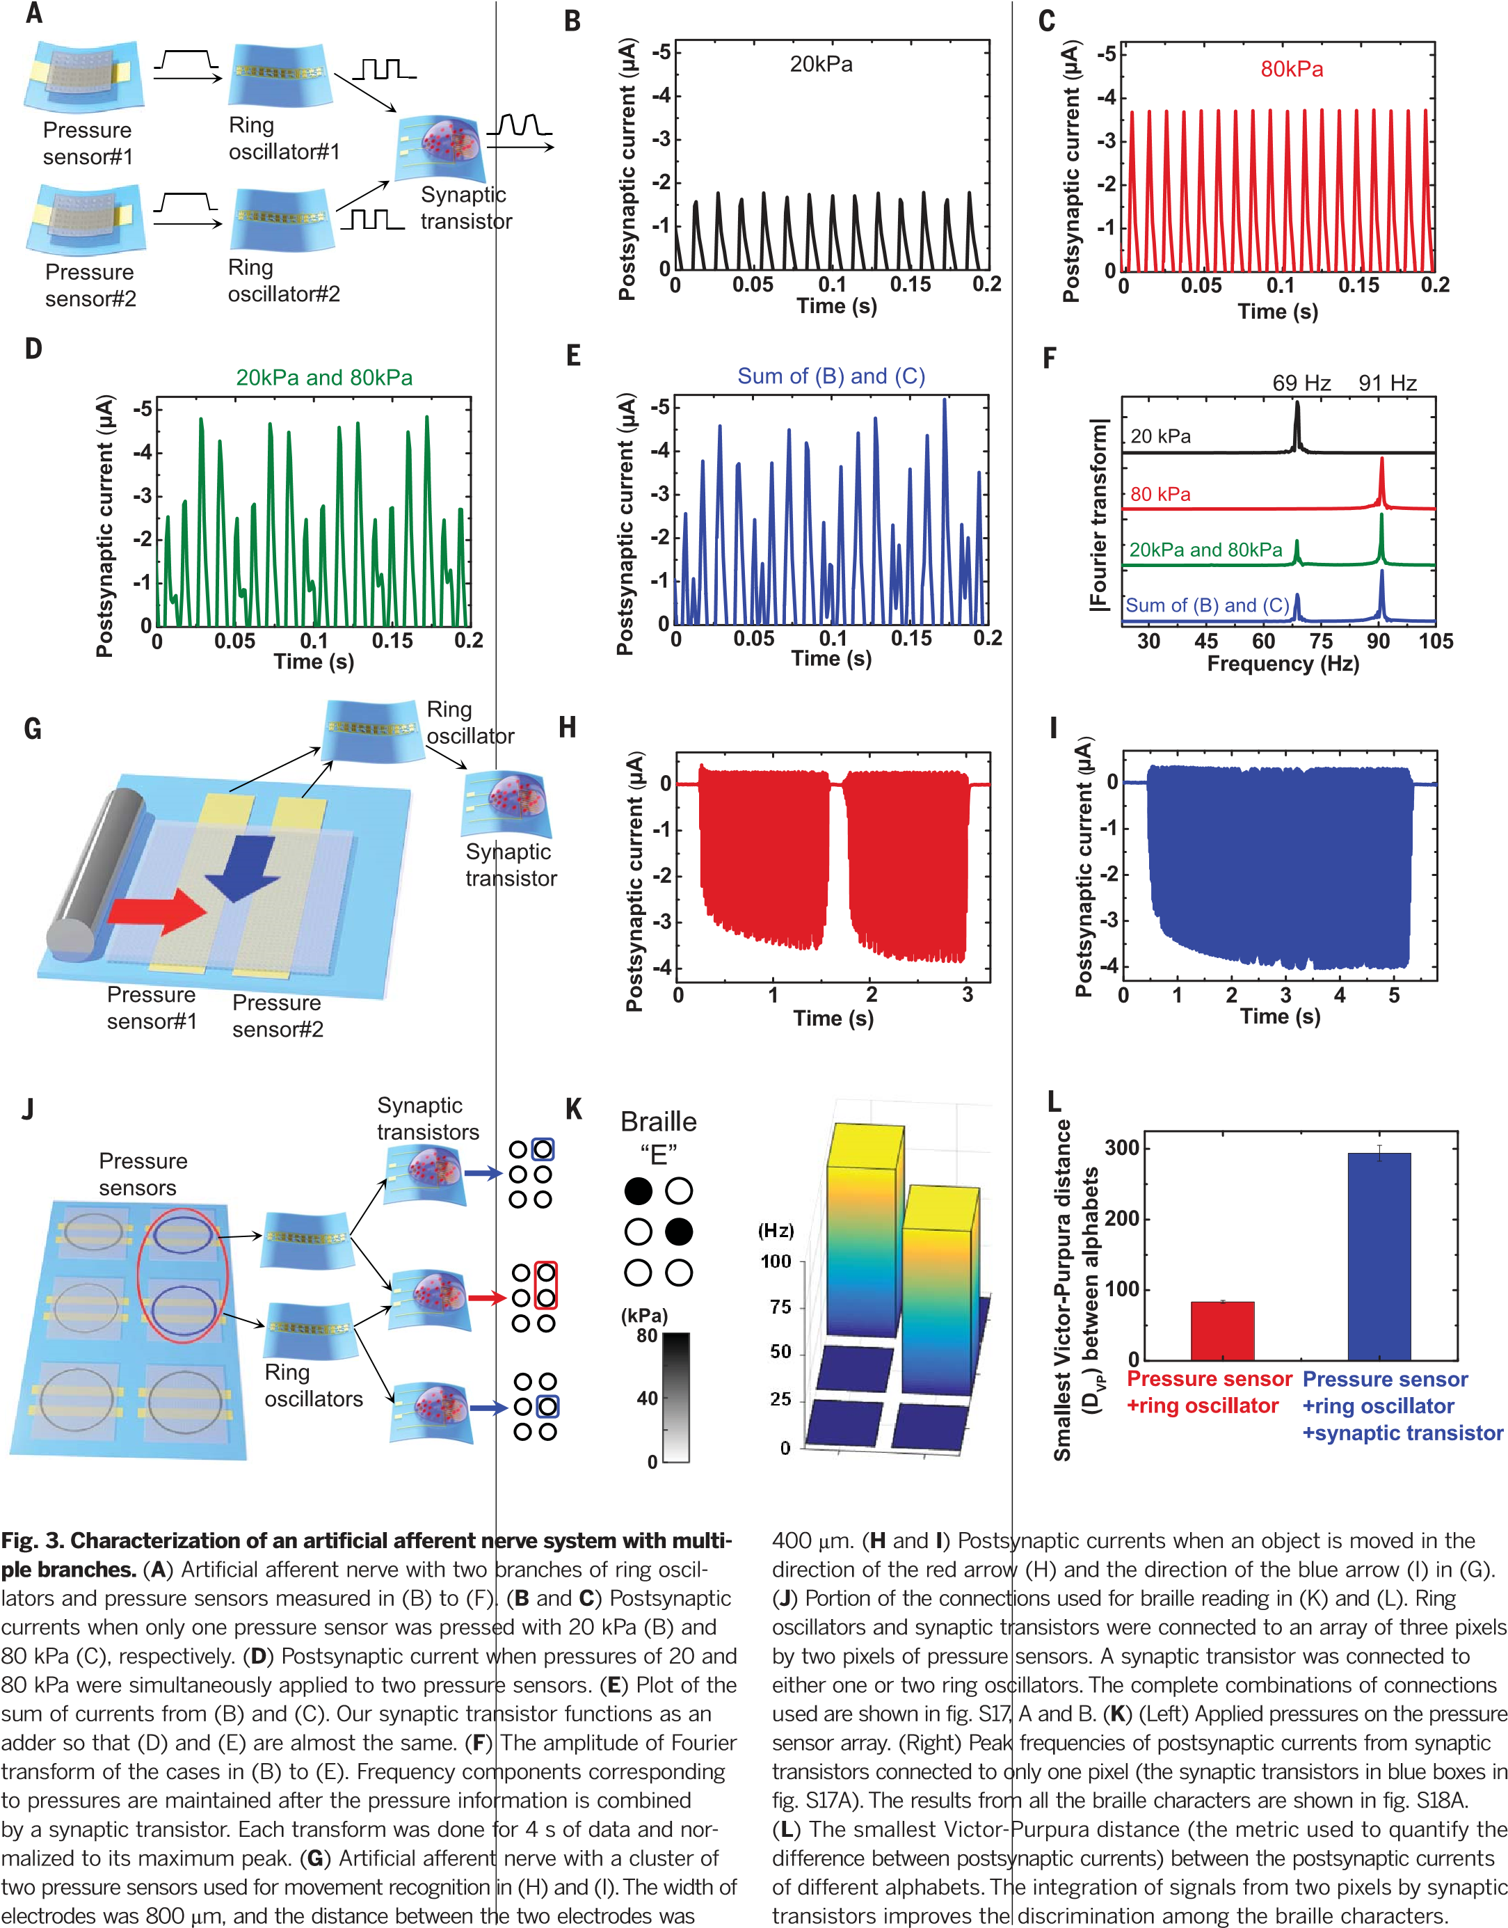

on November 27, 2019

[http://science.sciencemag.org](http://science.sciencemag.org/)

[/](http://science.sciencemag.org/)

Downloaded from

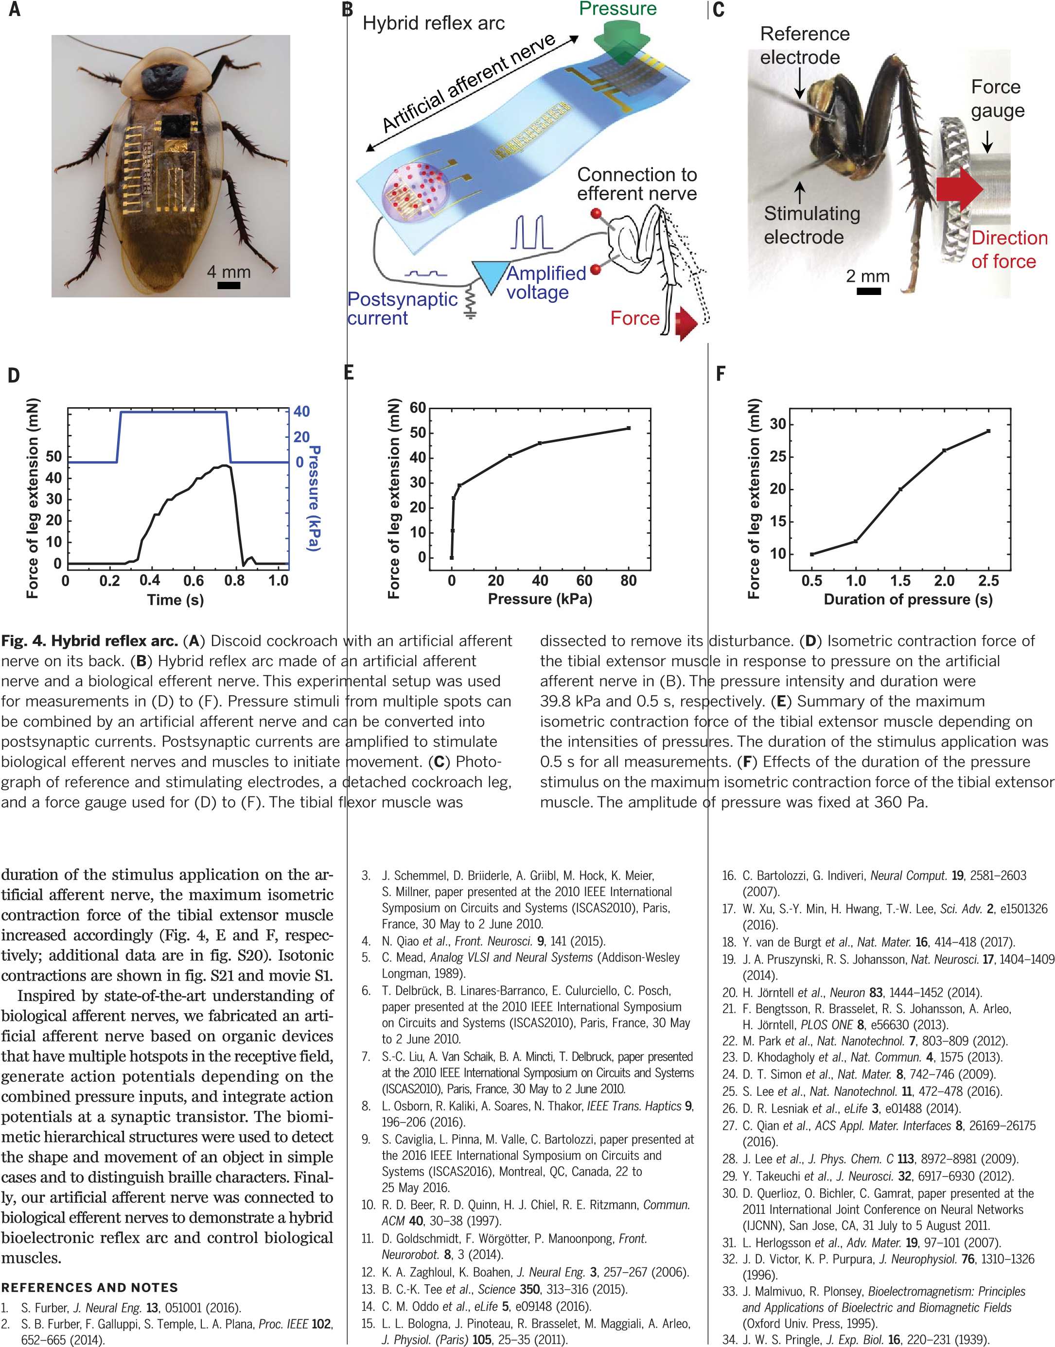1. 2.

on November 27, 2019

[/](http://science.sciencemag.org/)

[http://science.sciencemag.org](http://science.sciencemag.org/)

Downloaded from

ACKNOWLEDGMENTS

We thank Y. Park, J. H. Jang, and J. Kim for theoretical background; J. Lopez for suggestions; and M. He for providing the conjugated polymer P1. Funding: This work was supported by a National Research Foundation of Korea (NRF) grant (NRF-2016R1A3B1908431) funded by the Korean government (Ministry of Science and ICT); the Center for Advanced Soft-Electronics, funded by the Ministry of Science and ICT as a Global Frontier Project (CASE-2013M3A6A5073175); and the Creative-Pioneering Researchers Program through Seoul National University (SNU). Research carried out at Stanford

University is funded by Samsung Electronics. Y.Li. acknowledges NSS funding support from the Agency for Science, Technology and Research (A*STAR), Singapore. A.M.F. acknowledges postdoctoral fellowship support from the Natural Sciences and Engineering Research Council (NSERC) of Canada. R.P. acknowledges support from a Beatriu de Pinós fellowship (AGAUR 2014 BP-A 00094) from the Marie Curie Cofund. Part of this work was performed in the nano@Stanford labs (part of the National Nanotechnology Coordinated Infrastructure) and at the Stanford Nano Shared Facilities (SNSF), both of which are supported by the NSF under award ECCS-1542152. Author contributions:

Y.K., A.C., W.X., Z.B., and T.-W.L. conceived of and designed the overall experiments. Y.K., A.C., and W.X. carried out experiments and collected related data. Y.Li. contributed to cockroach stimulation experiments. J.Y.O. helped fabricate pressure sensors. D.S. and A.M.F. aided in transfers of thin-film devices. J.K., Y.Le., and

on November 27, 2019

[http://science.sciencemag.org](http://science.sciencemag.org/)

[/](http://science.sciencemag.org/)

Downloaded from

J.L. contributed to analyses of synaptic transistors. C.Z., S.N., and R.P. helped with electrical measurements. Z.B. and T.-W.L. initiated the study. Y.K., A.C., W.X., Z.B., and T.-W.L. analyzed all the data and cowrote the paper. All authors discussed the results and commented on the manuscript. Competing interests: Patents related to this work are planned. Data and materials availability: All data are available in the article or the supplementary materials.

SUPPLEMENTARY MATERIALS

[www.sciencemag.org/content/360/6392/998/suppl/DC1](http://www.sciencemag.org/content/360/6392/998/suppl/DC1)

Materials and Methods

Supplementary Text

Figs. S1 to S21

Tables S1 and S2

References (35–37)

Movie S1

5 June 2017; accepted 18 April 2018

10.1126/science.aao0098



# **A bioinspired flexible organic artificial afferent nerve**

Yeongin Kim, Alex Chortos, Wentao Xu, Yuxin Liu, Jin Young Oh, Donghee Son, Jiheong Kang, Amir M. Foudeh, Chenxin

Zhu, Yeongjun Lee, Simiao Niu, Jia Liu, Raphael Pfattner, Zhenan Bao and Tae-Woo Lee

*Science* **360** (6392), 998-1003.

DOI: 10.1126/science.aao0098

## I've got a feeling

Sensory (or afferent) nerves bring sensations of touch, pain, or temperature variation to the central nervous system and brain. Using the tools and materials of organic electronics, Kim *et al.* combined a pressure sensor, a ring oscillator, and an ion gel−gated transistor to form an artificial mechanoreceptor (see the Perspective by Bartolozzi). The combination allows for the sensing of multiple pressure inputs, which can be converted into a sensor signal and used to drive the motion of a cockroach leg in an oscillatory pattern. *Science*, this issue p. 998; see also p. 966

on November 27, 2019

[http://science.sciencemag.org](http://science.sciencemag.org/)

[/](http://science.sciencemag.org/)

Downloaded from

|  |  |
| --- | --- |
| **ARTICLE TOOLS** | <http://science.sciencemag.org/content/360/6392/998> |
| **SUPPLEMENTARY MATERIALS** | <http://science.sciencemag.org/content/suppl/2018/05/30/360.6392.998.DC1> |
| **RELATED CONTENT** | <http://science.sciencemag.org/content/sci/360/6392/966.full>file:/content  <http://stm.sciencemag.org/content/scitransmed/6/257/257ra138.full><http://stm.sciencemag.org/content/scitransmed/8/362/362ra142.full><http://stm.sciencemag.org/content/scitransmed/6/222/222ra19.full><http://stm.sciencemag.org/content/scitransmed/10/432/eaao6990.full><http://stm.sciencemag.org/content/scitransmed/10/443/eaap8373.full> |
| **REFERENCES** | This article cites 30 articles, 4 of which you can access for free <http://science.sciencemag.org/content/360/6392/998#BIBL> |
| **PERMISSIONS** | <http://www.sciencemag.org/help/reprints-and-permissions> |

Use of this article is subject to the [Terms of Service](http://www.sciencemag.org/about/terms-service)

*Science* (print ISSN 0036-8075; online ISSN 1095-9203) is published by the American Association for the Advancement of Science, 1200 New York Avenue NW, Washington, DC 20005. The title *Science* is a registered trademark of AAAS.

Copyright © 2018 The Authors, some rights reserved; exclusive licensee American Association for the Advancement of

Science. No claim to original U.S. Government Works